515. Find Largest Value in Each Tree Row

Medium
3.3K
106

Companies
Given the root of a binary tree, return an array of the largest value in each row of the tree (0-indexed).

Example 1:
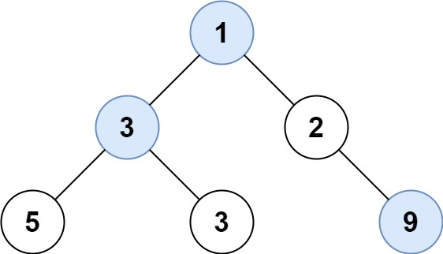
Input: root = [1,3,2,5,3,null,9]
Output: [1,3,9]
Example 2:
Input: root = [1,2,3]
Output: [1,3]

Constraints:
- The number of nodes in the tree will be in the range [0, 104].
- -231 <= Node.val <= 231 - 1

